**MSE 485 project**

Initialization:

Monte Carlo simulation in this project is carried under an NPT ensemble (isothermal, isobaric, and fixed number of atoms). The positions of atoms follow a BCC lattice configuration. To set up this specific structure, we are going to use tools in ASE python packages. (Check Atoms class and bulk class in ASE.) To verify we are getting correct configuration in our box, a 3D visualization tool is used (for details see view function in ASE). All particles in boxes should have normalized coordinates such that $S_{x, i}$, $S_{y, i}$, and $S_{z, i}$ remain the same after rescaling of volume. Here *i* stands for atom number with *i $∈(1, N$* ). The normalization formula is given by Formula 1 below.

 *Formula 1*

We can check the effect of volume change using the 3D view of atoms. The atoms should move apart from each other as we enlarge the volume of the box. The change in distance should be proportional to the change in length of box in that direction.

Monte Carlo move:

Once we finish our initialization, we can start our implementation of Monte Carlo algorithm. There are two types of different moves for each particle to take. The first is volume rescaling move, and the second is random particle displacement move. Details of these two moves are included in the flowchart below.

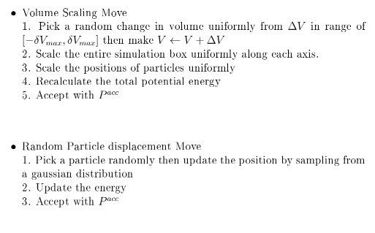

The frequency of volume rescaling moves (f) is taken from uniform distribution [0,1] randomly. If the frequency is less than the 1/(N+1), where N is the number of particles, we do the volume update. Otherwise, a normal position move is taken. The acceptance ratio $P^{acc}$ is given in Formula 2 below.

 *Formula 2*

EAM potential:

The potential energy in Monte Carlo is calculated using EAM potential. The formula for an EAM potential is given below in *Formula 3*.

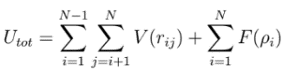 *Formula 3*

We have a built-in calculator for EAM inside the Atom object we initialize. However, to use this calculator, we need to provide a file (suffixes such as. eam or. fs) as an input argument. The file can either be taken from an online source or generated custom. The components of the file are listed in *Figure 1* below.

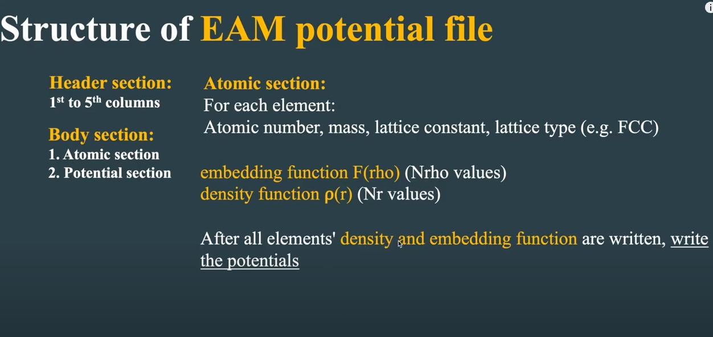

*Figure 1* components of an EAM potential file

A detailed description of EAM components is included in this GitHub repository. <https://github.com/NextZenStudent/EAM-potential>

Results:

Some useful properties to inspect.

1. Bulk modulus (derivative of potential versus volume)
2. Lattice constant ratio c/a, a
3. Radial distribution and structure factor (if have time)

Current problems:

* The current temperature of initial atom configuration is 0K. We need to find a way to give atom different velocities to run simulations at different temperatures.
* We are currently using EAM potential calculator from an online source. Not sure about it is reliable or not.
* Another thing we can do is to write for another potential called MEAM. The details still needs to be discussed.